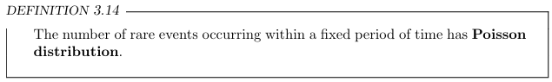
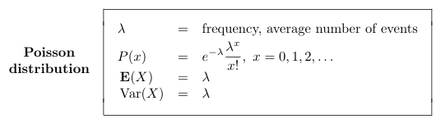
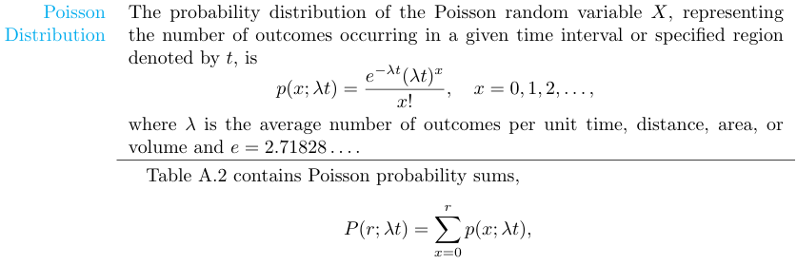
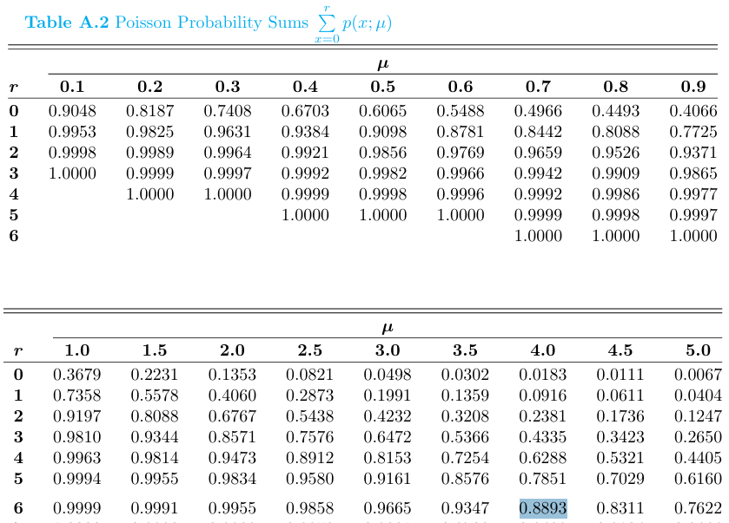
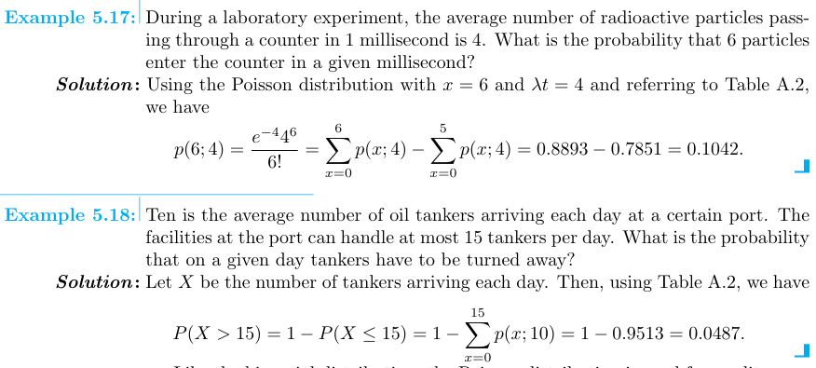

5.56
On average, 3 traffic accidents per month occur at a certain intersection. What is the probability that in any given month at this intersection (a) exactly 5 accidents will occur? (b) fewer than 3 accidents will occur? (c) at least 2 accidents will occur?
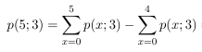
= 0.9161 - 0.8153 = 0.1457
$$= \sum_{x=0}^{2}{p(x;3)}= 0.4232$$
$$=1-\sum_{x=0}^{1}{P\left(x;3\right)}=1- 0.1991=0.8009$$

5.58
A certain area of the eastern United States is, on average, hit by 6 hurricanes a year. Find the probability that in a given year that area will be hit by (a) fewer than 4 hurricanes; (b) anywhere from 6 to 8 hurricanes.
$$= \sum_{x=0}^{3}{P\left(x;6\right)= 0.1512}$$
$$=\sum_{x=0}^{8}{P(x;6)}- \sum_{x=0}^{5}{P\left(x;6\right)}= 0.8472- 0.4457=0.4015$$

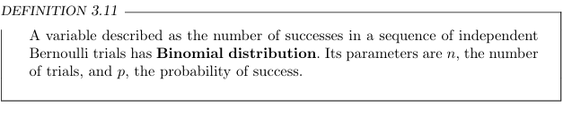
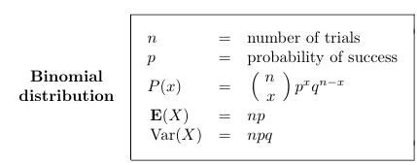
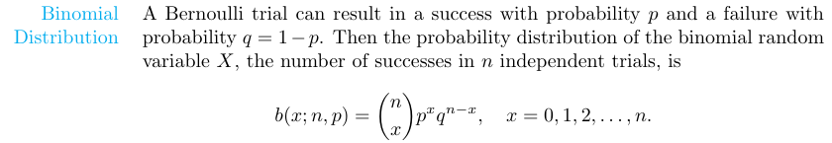

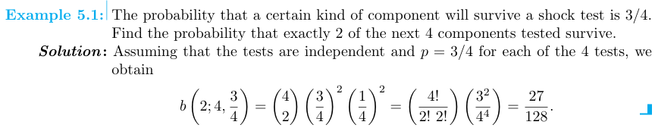

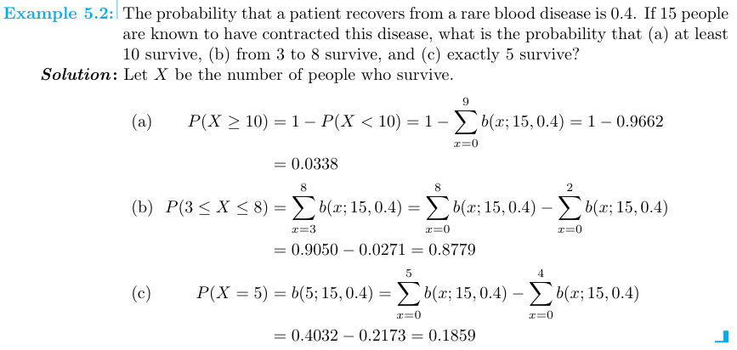

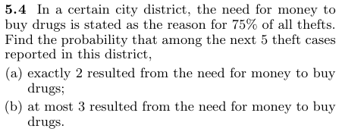
Solution:
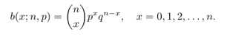
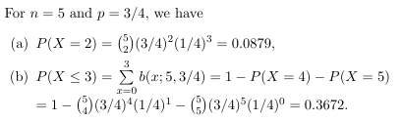
5.13
A national study that examined attitudes about antidepressants revealed that approximately 70% of respondents believe “antidepressants do not really cure anything; they just cover up the real trouble.” According to this study, what is the probability that at least 3 of the next 5 people selected at random will hold this opinion?
Solution:
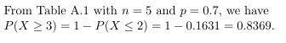
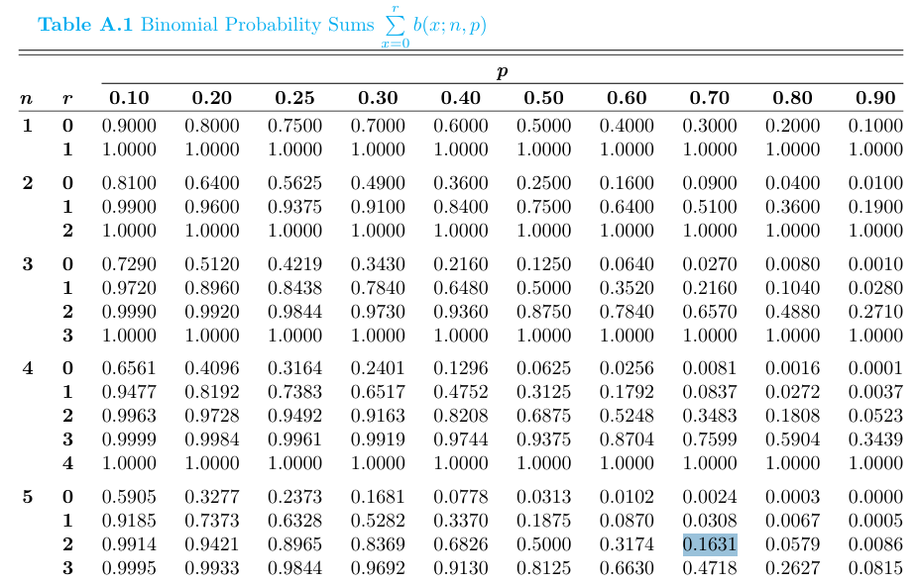
5.17 If X represents the number of people in Exercise 5.13 who believe that antidepressants do not cure but only cover up the real problem, find the mean and variance of X when 5 people are selected at random.

